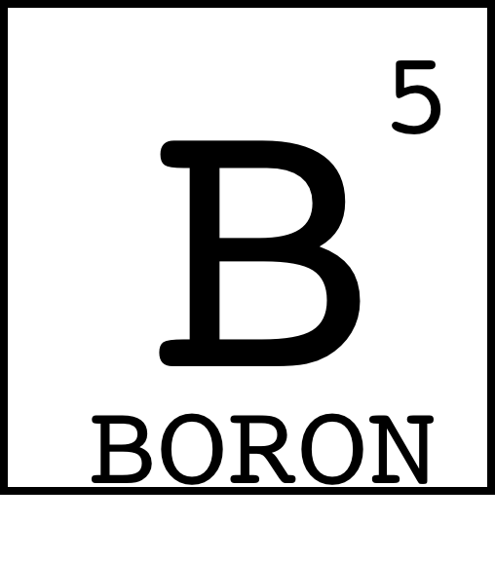
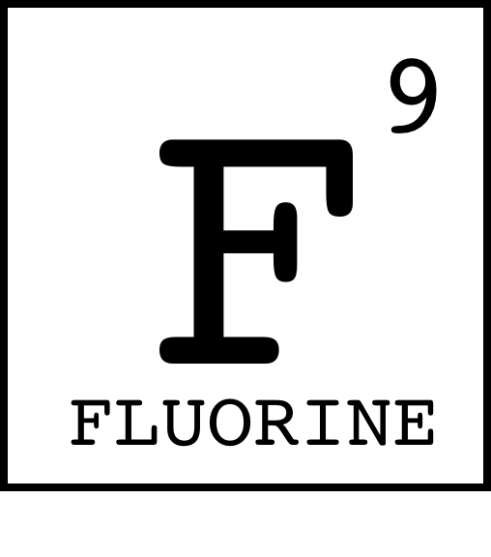
Chemistry Gossip
Write the chemical symbols for the elements found in each question.

- I bet that outfit is made of Copper and Tellurium, because it is so…
______________________________________________________
- Did you hear that Oxygen is going out with Magnesium?
______________________________________________________
- Sulfur, Tungsten, and Silver, they’ve got so much…
______________________________________________________
- Are you friends with Nitrogen and Oxygen?
______________________________________________________
- I saw Sulfur, Uranium, and Phosphorus and asked…
______________________________________________________
- Ruthenium saw Oxygen and Potassium and asked…
______________________________________________________
- Have you heard? Lutetium and Vanadium are in…
______________________________________________________
- Hydrogen and Iodine really know how to get a conversation going…
______________________________________________________
- I heard that Sulfur was going out with Oxygen, but then Tungsten, Hydrogen, and Astatine were like…
______________________________________________________
- I guess I’ll TTYL, Atomic Number of Beryllium, Sulfur, Uranium, Rhenium.
______________________________________________________

