Name: ___________________________ Period: ____________
Biotechnology Notes
Biotechnology - The manipulation of _____________________________________________________ to achieve a goal
Applications of Biotechnology:
1. Biofuels - A type of energy derived from renewable ______________________ or organic matter.
Examples of biofuels include _________________________________
2. Genetic Engineering - When the manipulation involves the ___________________________________________
Genes are added, _________________________or ______________________________
- Genetically Engineered Human Insulin From Bacteria
_____________________________________________________ inserted into bacteria genome
____________________________________________________ are able to produce human insulin
3. Bioremediation - Using __________________ and other living things to ____________________ the environment
- Example: Genetically engineered __________________ can be used to clean up an ___________________.
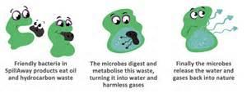
4. Genetically Modified Organisms
Organisms that ______________________________________
___________________________________________________
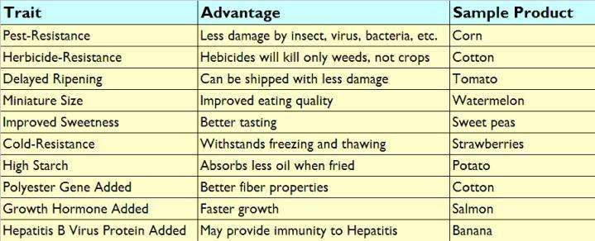
*Also called __________________
Genetically Modified Plants
The goal is to ___________________
______________________________
Genetically Modified Animals
Produce beneficial _________________
________________________________________________.

5. Cloning
Organisms that ______________________________________________________________________________
Cloning began in _______________________
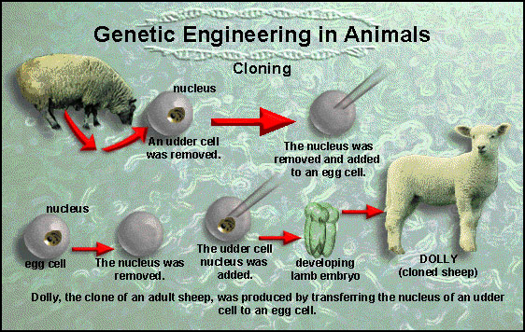
____________________________________

____________________- first animal cloned
from adult cell

Biotechnology Ethics
Society’s responsibilities regarding uses of
________________________________________

What do you think???
Is it okay for us to use biotechnology anyway we want? When is it good? When is it bad?
Pros (Good) | Cons (Bad)
1. | 1.
2. | 2.
3. | 3.

