Name: ___________________________________________
Directions: You must cite where you found the information please. Example: textbook page 325, notes, etc. Google is not an option. Thank you.
Multiple Choice:
- Magma that forces its way into rocks and hardens is called a(n):
  - Extrusion
  - Fault
  - Unconformity
  - Intrusion
- A petrified fossil forms when
  - An organism is frozen
  - Minerals replace all of part of an organism
  - An organism becomes trapped in amber
  - Gases escape from the organism and leave carbon behind
- The earliest forms of life appeared during
  - The Paleozoic Era
  - The Cenozoic Era
  - Precambrian Time
  - The Mesozoic Era
- On the geologic time scale, eras are divided into
  - Ages
  - Indexes
  - Periods
  - Relative dates
- Fossils provide evidence for all of the following EXCEPT for
  - Changes in the Earth’s surface
  - How the Earth originally formed
  - How environments on Earth have changed over time
  - How groups of organisms have changed over time
- In the Cambrian Explosion,
  - The supercontinent broke apart
  - An asteroid collided with Earth
  - A great number of different organisms evolved
  - Mammals spread into every environment on Earth
- Most fossils form when organisms die and are buried in
  - Sediment
  - Faults
  - Unconformities
  - Ice
- The Mesozoic Era is often called the
  - Age of Mammals
  - Age of Fish
  - Age of Reptiles
  - Age of Amphibians

- Scientists use radioactive dating to
  - Determine the absolute ages of rocks
  - Discover the source of index fossils
  - Determine the relative ages of extrusions
  - Find and trace fossils in igneous rock
- Reptiles evolved from
  - Dinosaurs
  - Mammals
  - Birds
  - Amphibians
True OR False:
- Dinosaurs “ruled” Earth during the Paleozoic Era. _____
- A scientist who studies fossils is called a(n) paleontologist. _____
- Geologists often use potassium-40 to date materials that lived up to about 50,000 years ago. _____
- Animals without backbones are called invertebrates. _____
- Index fossils are useful because they tell the absolute ages of rock layers. _____
Fill in the Blank:
- The gradual change in living things over long periods of time is called _______________.
- The _______________ of a radioactive element is the time it takes for half of the radioactive atoms to decay.
- Fossils are almost always found in _______________ rock.
- Plants and animals first reached land during the _______________ Era.
- The earliest life forms were probably similar to present-day _______________.

Critical Thinking:
- Interpreting Diagrams
Use the diagram below to answer questions 21-23.
Precambrian Time | Paleozoic Era | Mesozoic Era | Cenozoic Era

- What is this called, and why do geologists use it?

- Where on this figure would you place a mark for when Pangea formed?

- Where on this figure would you place a mark for when humans appeared?

Use the diagram below to answer questions 24 and 25.
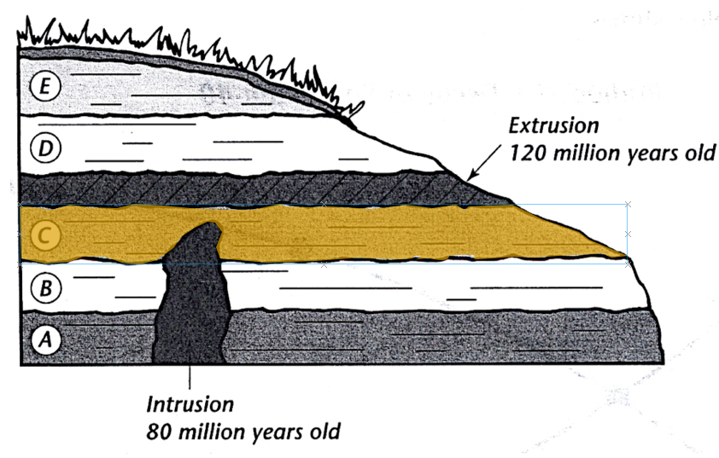

- What is the age of layer C? Explain your answer.

- If erosion wore away layer E and then a new layer formed, what would be the result?

- Essays

- What is the law of superposition, and how is it used?
- What are index fossils, are how are they used? Describe an example in your explanation.
- Describe how a cast is related to a mold.
- What occurred at the end of the Cretaceous Period, and how did it affect life on Earth? Describe one hypothesis for why this event occurred.
- What does the fossil record show about how life has changed on earth?

