Viruses

Characteristics: NOT ________________
Do not use _____________ energy to grow;
Can’t make _____________ food or produce _____________; Are able to ________________ in host cell

Host: Organism that is __________________ of energy for the virus

Parasite: Virus causes _________________ to host cell --- almost ____________ viruses destroy the cell

Shapes: _______________- virus in a bacteria cell--__________ shape
Other types- round, bricklike, threads or _________________
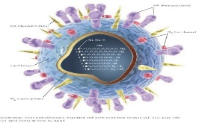
Size: ________nanometer to _______nanometer

Named: For _________________________, places
_________, or disease they ____________

Structure: Protein coat- _____________________ to fit certain host
Inner core- ______________________ material

Reproduce: Must be _________________ ___________ cell to produce a new virus

Active virus: Immediately _____________ and take over cell; ex cold or rhinovirus

Hidden virus: Enter and _____________ temporarily;
Ex. HIV virus and cold sore (herpes) virus

Negative: DISEASE
Short term- cold & flu
Long-term- rabies, distemper, HIV

Positive: Gene _____________; virus acts as a ______________ to redirect cell for medical treatment: ex Cystic Fibrous

Bacteria

- Cell Structure: ___________ cell; _________________ (no nucleus)
- Cell ___________ & membrane; cytoplasm &_________________
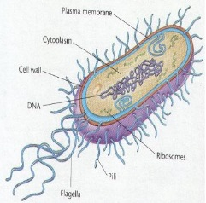
- Genetic material in _____________________like a tangled string

- Movement: ____________________(whiplike tail) OR ___________ currents OR ______________ currents
- Shape: Spherical, rod, or spiral

- Size: 0 to ½ ______________________
- Food: Some are _______________________ so photosynthesis or chemical synthesis for __________
- Some are ___________________ so _____________ food like decaying leaves, . . .

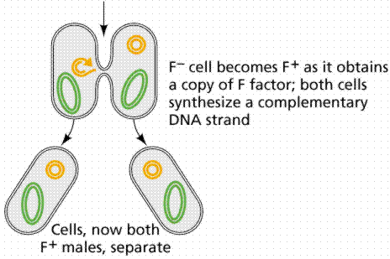
- Energy Source: respiration—most use _____________but some are ____________
- Reproduce: Can reproduce as often as every 20 minutes;
- Asexual by ___________ ______________--cell copies & splits into _________ cells.
- Sexual- _____ _______________bacteria combine genetic material thru a threadlike bridge to produce a ______________ cell. Called ________________
- Form __________________-when trying to survive harsh conditions. It forms a spore within the bacteria cell.
- It contains genetic material and cytoplasm and can survive for many years. Then can be released and carried to a new place. Ex. Clostidium botulinum–when conditions become favorable, they open up and begin to multiply

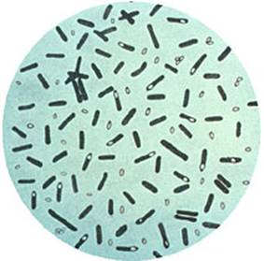
- Role of Bacteria: Positive: ____________ production; recycling and ____________ of ______________ matter; food production—pickles, vinegar; medicine such as insulin; body processes such as digestion
- Negative: _____________ food, ____________ such as strep throat
- Pasteurization: method to ___________ bacteria in foods such as milk products; uses high _______________ and does not alter taste of food

Infectious Disease

- What is an infectious disease?
  - Illness that passes from one organism to another
- How are they spread?
  - __________________, swallowed or ingested, enter through moist body cavities—ie. Nose
- Bacteria infections are treated with:
  - ________________ which are chemicals that can kill only the bacteria
- Viral ailments are treated:
  - Over the counter medications can relieve symptoms of most viral infections such as __________or ____________
  - Some antiviral drugs are prescription such as ones for _______________
- How prevented?
  - ____________ are introduced to the body to stimulate the production of chemicals to destroy the virus or bacteria.
- Antibiotic Resistance is:
  - When bacteria ___________ to resist the chemical affects of the antibiotic so the bacteria survives the antibiotic

Protists/Parasites

Eukaroytes that CANNOT be classified in the animal, plant, or fungi kingdoms. Known as “odds & ends” kingdom. All live in moist surroundings. Can be uni or multicellular; may be auto or hetrotrophs; some move and some are stationary.

- Unicellular – composed of only _______ cell.
- Multicellular – composed of ____________ than one cell.
- Eukaryote: an organism that contains membrane-bound organelles and genetic material within a nucleus.
- Prokaryote: a unicellular organism that lacks a true nucleus and membrane-bound organelle.

Protozoans that are Parasites
  - Parasites are things that must have a _____ to survive.
  - Move in a wide variety of ways but must have a host to feed on.
  - Plasmodium a protozoa that causes ___________ has multiple hosts.
    - Usually spread by a mosquito biting an infected person then biting a healthy person

Fungi

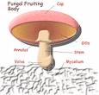
Fungi are:
Eukaryotes that have _________________ and are _____________________

Cell structure:
Arranged in structures called _____________. These are branching, threadlike ____________ that make up the bodies of _________________ fungi

Food:
Absorb food through the hyphae that grow on food source

Reproduce:
Lightweight spores are surrounded by a protective coating and can be carried easily through water or air to a new site.
Spores reproduce in ______________ ___________
Most reproduce sexually & asexually.
Cells at the tip of the _____________________ divide to form spores & grow into fungi that are identical to parent. _____________ yeast undergoes ______________ (asexual). There are no spores. Yeast buds and breaks away from parent.
When ______ hyphae from ______ fungi grow _______________ genetic material is _____________. Spores are different from either parent. This is sexual reproduction.

Classification:
Grouped according to reproduction—sac fungi, club fungi, or zygote fungi

Role in Nature:
+ ________________ in nature-break down the chemicals in dead organisms
__________- yeast in bread; mold to blue cheese
________________- penicillin
Lichens- ___________ + ___________ in community – sensitive to air pollution & indicate health of an area
Plant roots grow into hyphae underground spread out and absorb water and nutrients from soil, help plant grow better

