Name: _______________________________________________ Date: ____________ Period: ______ ASSIGN
Practice with Atomic Structure
Identifying atomic structure: For each atom below, say how many protons, neutrons, and electrons it has. Then, write its atomic number, atomic mass number, and the charge of the atom.
 | - Boron  # protons: __________  # neutrons: _________  # electrons: _________  Atomic #: __________  Atomic Mass #: _____  Charge: ___________ |  | - Aluminum  # protons: __________  # neutrons: _________  # electrons: _________  Atomic #: __________  Atomic Mass #: _____  Charge: ___________
 | - Oxygen  # protons: __________  # neutrons: _________  # electrons: _________  Atomic #: __________  Atomic Mass #: _____  Charge: ___________ |  | - Helium  # protons: __________  # neutrons: _________  # electrons: _________  Atomic #: __________  Atomic Mass #: _____  Charge: ___________
Draw an Atom: Calculate the number of protons, neutrons, and electrons for each atom. Then draw the atom in the space provided. Write the charges inside the protons and electrons (see above).
 | - Mercury  # protons: __________  # neutrons: _________  # electrons: _________  Atomic #: 80  Atomic Mass #: 201  Charge: +2 |  | - Krypton  # protons: __________  # neutrons: _________  # electrons: _________  Atomic #: 36  Atomic Mass #: 84  Charge: 0
 | - Beryllium  # protons: __________  # neutrons: _________  # electrons: _________  Atomic #: 4  Atomic Mass #: 9  Charge: +2 |  | - Bromine  # protons: __________  # neutrons: _________  # electrons: _________  Atomic #: 35  Atomic Mass #: 80  Charge: -1

Chart: Fill in the chart below.
Element | Atomic Number | Atomic Mass # | # Protons | # Neutrons | # Electrons
Helium |  |  | 2
Sulfur (-2) |  | 33 | 16
Potassium -39 (+1) | 19
Iodine (-1) | 53 | 127
Silver |  | 108 | 47
Cobalt – 59 (+2) | 27
Lithium – 7 (+1) | 3
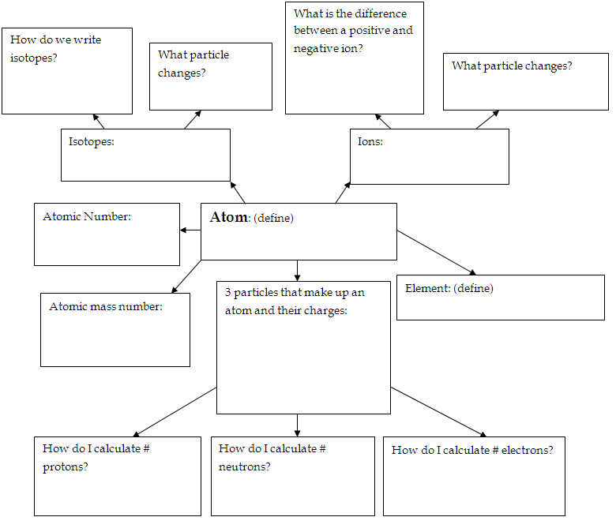
Graphic Organizer: Fill in the graphic organizer below. Use your Atomic Structure notes to help you.
Summarize: Summarize what YOU think is important to know about atomic structure.

