- Relative age is the age of a rock layer (or the fossils it contains) compared to other layers.
can be determined by looking at the position of rock layers (Law of Superposition)
- Absolute age is the numeric age of a layer of rocks or fossils.
can be determined by using radioactive dating.

1a. In your own words, define the term radioactive decay.
____________________________________________________________________________________________________________________________________
1b. How does the composition of a rock containing a radioactive element change over time?
____________________________________________________________________________________________________________________________________
1c. How is a radioactive element’s rate of decay like the ticking of a clock? Explain.
____________________________________________________________________________________________________________________________________
2a. What method do geologists use to determine the absolute age of a rock?
__________________________________________________________________
2b. Why is it difficult to determine the absolute age of a sedimentary rock?
____________________________________________________________________________________________________________________________________
2c. A geologist finds a fossil in a layer of sedimentary rock that lies in between two igneous extrusions. How could the geologist determine the age of the fossil?
____________________________________________________________________________________________________________________________________
3. What percentage of a radioactive element will remain after seven half-lives?
__________________________________________________________________
PART I: RADIOACTIVE DECAY
Rocks are a form of matter. All the matter you see, including rocks, is made of tiny particles called atoms. When all the atoms in a particular type of matter are the same, the matter is called an element. Carbon, oxygen, iron, leads, and potassium are just some of the more than 110 currently known elements.
Most elements are stable. They do not change under normal conditions. But some elements exist in forms that are unstable. Over time, these elements break down, or decay, by releasing particles and energy in a process called radioactive decay. These unstable elements are said to be radioactive. During radioactive decay, the atoms of one element break down to form atoms of another element.
Radioactive elements occur naturally in igneous rocks. Scientists use the rate at which these elements decay to calculate the rock’s age. You calculate your age based on a specific day—your birthday. What’s the “birthday” of a rock? For an igneous rock, that “birthday” is when it first hardens to become rock. As a radioactive element within the igneous rock decays, it changes slowly over time. The amount of the radioactive element goes down. But the amount of the new element goes up.
The rate of decay of each radioactive element is constant—it never changes. This rate of decay is the element’s half-life. The half-life of a radioactive element is the time it takes for half of the radioactive atoms to decay. You can see in Figure 1 how a radio active element decays over time.

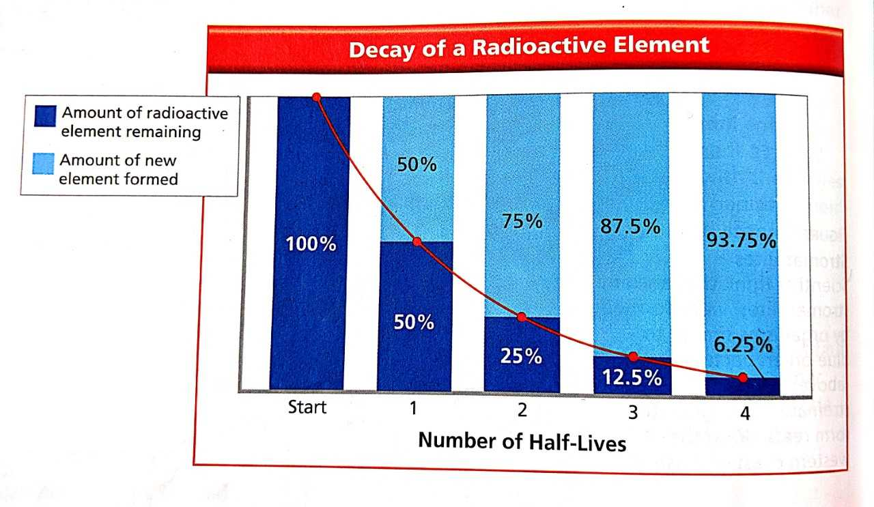
Figure 1. The half-life of a radioactive element is the amount of time it takes for half of the radioactive atoms to decay.
PART II: DETERMINING ABSOLUTE AGES
Geologists use radioactive dating to determine the absolute ages of rocks. In radioactive dating, scientists first determine the amount of a radioactive element in a rock. Then they compare that amount with the amount of the stable element into which the radioactive element decays. Figure 2 lists several common radioactive elements and their half-lives.
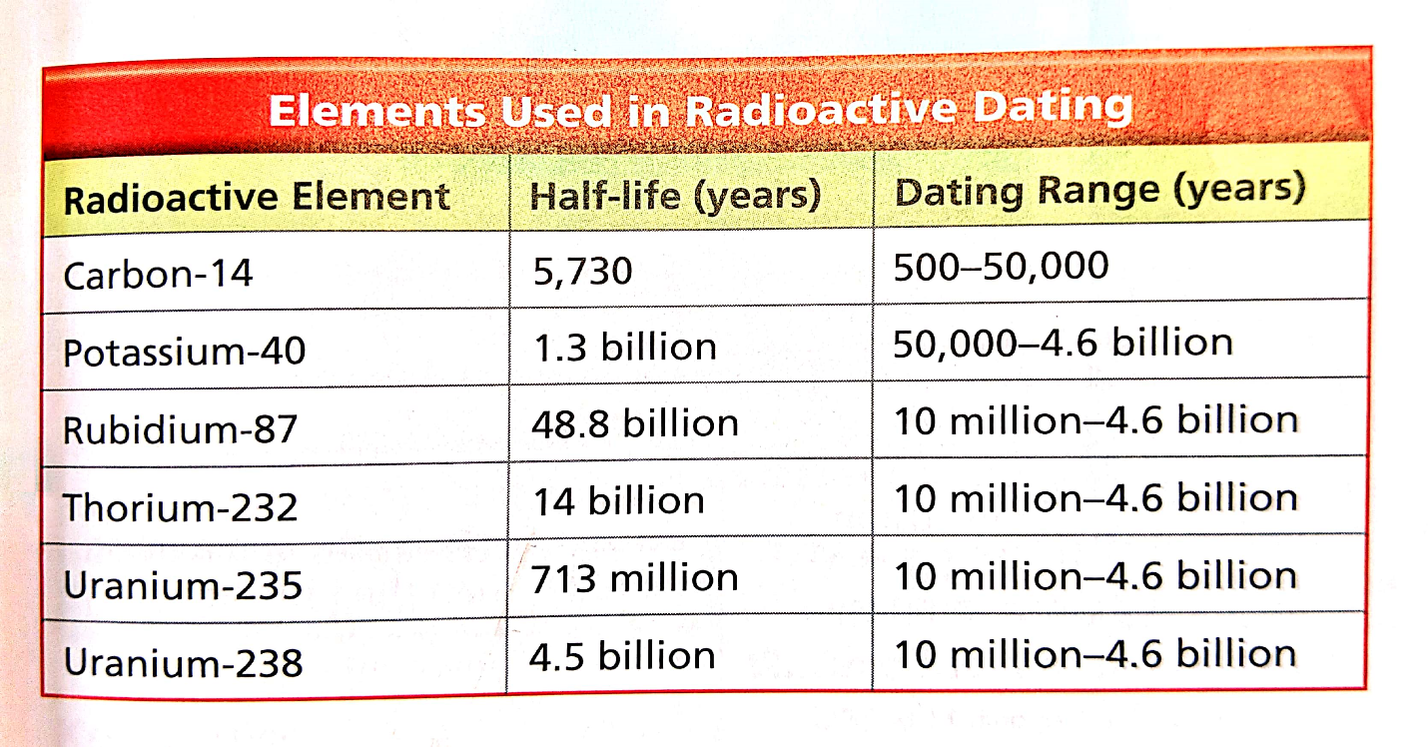
Figure 2. The half-lives of different radioactive elements vary greatly.

Potassium-Argon Dating
Scientists often date rocks using potassium-40. This form of potassium decays to stable argon-40 and has a half-life of 1.3 billion years. Potassium-40 is useful in dating the most ancient rocks because of its long half-life.

Carbon-14 Dating
A radioactive form of carbon is carbon-14. All plants and animals contain carbon, including some carbon-14. As plants and animals grow, carbon atoms are added to their tissues. After an organism dies, no more carbon is added. But the carbon-14 in the organism’s body decays. It changes to stable nitrogen-14. To determine the age of a sample, scientists measure the amount of carbon-14 that is left in the organism’s remains. From this amount, they can determine its absolute age. Carbon-14 has been used to date fossils such as frozen mammoths, as well as pieces of wood and bone. Carbon-14 even has been used to date the skeletons of prehistoric humans.

Carbon-14 is very useful in dating materials from plants and animals that lived up to about 50,000 years ago. Carbon-14 has a half-life of only 5,730 years. For this reason, it can’t be used to date very ancient fossils or rocks. The amount of carbon-14 left would be too small to measure accurately.
Radioactive Dating of Rock Layers
Radioactive dating works well for igneous rocks, but not for sedimentary rocks. The rock particles in sedimentary rocks are from other rocks, all of different ages. Radioactive dating would provide the age of the particles. It would not provide the age of the sedimentary rock.

How, then, do scientists date sedimentary rock layers? They date the igneous intrusions and extrusions near the sedimentary rock layers. Look at Figure 3. As you can see, sedimentary rock (sandstone) above an igneous intrusion must by younger than that intrusion.

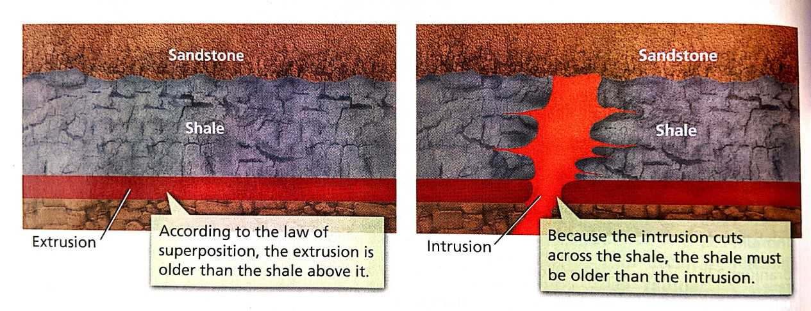
Figure 3. A layer of shale forms above an extrusion (left). Later (right), an intrusion crosses the shale.

