# Name: ___________________

# My Shad notes:

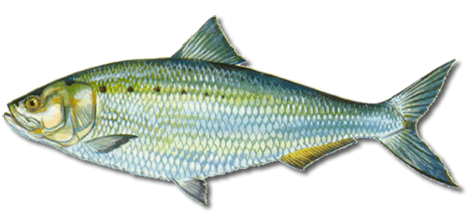

# http://www.gotmyfishon.com/files/images/fish/american-shad.png?0My Shad haiku poem:

A Haiku is a poem written in this format:

**first line, 5 syllables   
second line, 7 syllables   
third line, 5 syllables**  
  
Write a poem about the American Shad, its life, surroundings, history, etc.

using the Haiku format shown above. Here is an example:

**spring**

**Butterflies flying  
Their orange wings touch the sun  
They perch on fresh leaves**

# Pond life:

**Draw** and **identify** three organisms that

you found in the pond.

 

# Why is this all important to me?

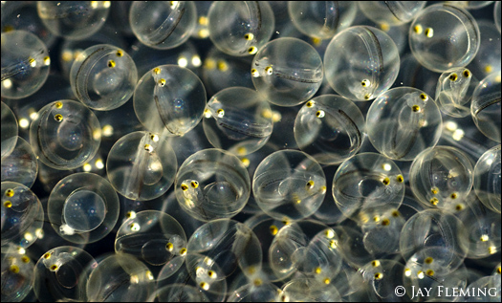 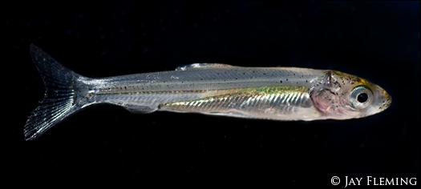

[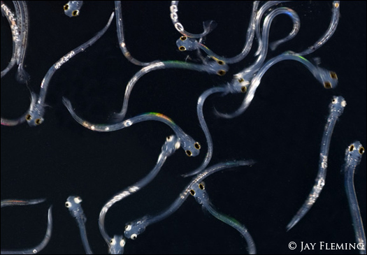](http://www.jayflemingphotography.com/wp-content/uploads/AS-Larvae-©-JPF.jpg) 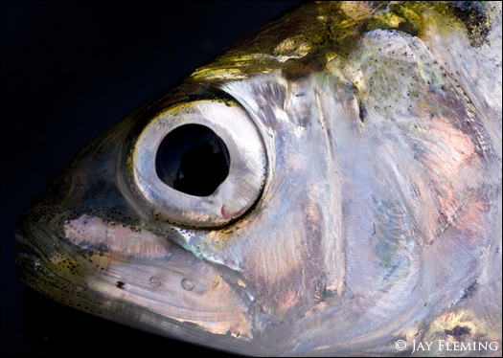

# Why is this all important to me?

 

[](http://www.jayflemingphotography.com/wp-content/uploads/AS-Larvae-©-JPF.jpg) 