Name:_______________

Virus Lab

Predicting the Spread of a Disease

Purpose/Objective:
To demonstrate how a virus can spread through a population
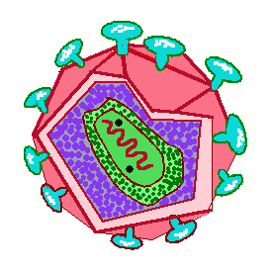

Materials

- 35 plastic cups numbered 1-35
- Secret Virus Indicator

Methods

1) Copy the data table you see under the Data/Results section of this lab.

2) Obtain a cup numbered 1-35. Circle the number of the cup you have on your data table.

3) “Exchange fluids” with another person in the class. To do this, pour half of your cup into theirs. Then have them pour half of their cup back into yours. You both should end up with the same amount (= the original amount you started with). Record the number of the person you came in contact with under your number of your data table.

3) Repeat step 3 two more times, recording each time the number of the person you can in contact with.
Note: It is very important to record the numbers of the people you came in contact with in order.

4) Test all the cups with secret virus indicator solution to determine who contracted the virus (Your teacher will do this step).

5) Create a class table on the board similar to the one in the Data/Results section of the lab. Have the class generate the data needed to complete the table including who they came in contact with (in order) and if they had the virus (+) or did not have the virus (-).

Data/Results:

1 | 2 | 3 | 4 | 5
6 | 7 | 8 | 9 | 10
11 | 12 | 13 | 14 | 15
16 | 17 | 18 | 19 | 20
21 | 22 | 23 | 24 | 25
26 | 27 | 28 | 29 | 30
31 | 32 | 33 | 34 | 35

Key: Virus (+) / No Virus (-)

Discussion:

1) How many people did you exchange fluids with? How many people were involved in the activity?

2) How many people in the class ended up infected?

3) What percentage of the class was infected? Not infected?

4) What did the indicator represent?

5) Could you tell by looking at the liquid if it was infected before the indicator was added? Explain.

6) Could you determine who originally started with the virus? If so, who started with the virus? If you could determine who started with the virus, briefly explain the process that you used to come to this conclusion.

7) What factors could influence how fast a virus spreads through a group of people (population)? Give at least two (2) examples.

8) Relate this lab activity to the spread of HIV. Explain in no less than 3 sentences.

